

Semester Two Examination, 2022
Question/Answer booklet

MATHEMATICS
APPLICATIONS
UNITS 3&4

If required by your examination administrator, please place your student identification label in this box
Section One:
Calculator-free
WA student number: In figures

In words

Your name

Number of additional
answer booklets used
(if applicable):

Time allowed for this section
Reading time before commencing work: five minutes
Working time: fifty minutes

Materials required/recommended for this section
To be provided by the supervisor
This Question/Answer booklet
Formula sheet

To be provided by the candidate
Standard items: pens (blue/black preferred), pencils (including coloured), sharpener,
correction fluid/tape, eraser, ruler, highlighters

Special items: nil

Important note to candidates
No other items may be taken into the examination room. It is your responsibility to ensure that you do not have any unauthorised material. If you have any unauthorised material with you, hand it to the supervisor before reading any further.

Structure of this paper

Section | Number of  questions  available | Number of  questions to  be answered | Working  time  (minutes) | Marks  available | Percentage  of  examination
Section One:  Calculator-free | 7 | 7 | 50 | 50 | 35
Section Two:  Calculator-assumed | 12 | 12 | 100 | 99 | 65
 |  |  |  | Total | 100

Instructions to candidates

1. The rules for the conduct of examinations are detailed in the school handbook. Sitting this examination implies that you agree to abide by these rules.

2. Write your answers in this Question/Answer booklet preferably using a blue/black pen.
Do not use erasable or gel pens.

3. You must be careful to confine your answers to the specific question asked and to follow any instructions that are specific to a particular question.

4. Show all your working clearly. Your working should be in sufficient detail to allow your answers to be checked readily and for marks to be awarded for reasoning. Incorrect answers given without supporting reasoning cannot be allocated any marks. For any question or part question worth more than two marks, valid working or justification is required to receive full marks. If you repeat any question, ensure that you cancel the answer you do not wish to have marked.

5. It is recommended that you do not use pencil, except in diagrams.

6. Supplementary pages for planning/continuing your answers to questions are provided at the end of this Question/Answer booklet. If you use these pages to continue an answer, indicate at the original answer where the answer is continued, i.e. give the page number.

7. The Formula sheet is not to be handed in with your Question/Answer booklet.
Section One: Calculator-free 35% (50 Marks)
This section has seven questions. Answer all questions. Write your answers in the spaces provided.

Working time: 50 minutes.

Question 1 (6 marks)
(a) A farmer has four fields that are to be used to grow crops of barley, wheat, potatoes and turnips. Field $1$ is suitable for barley or potatoes, Field $2$ for wheat or turnips, Field $3$ for potatoes and Field $4$ for barley or wheat.

(i) Represent this information using a bipartite graph. (2 marks)

(ii) Given that all four crops must be grown at the same time, and only one crop can be grown per field, in which field should the farmer grow the crop of wheat? Justify your answer. (1 mark)

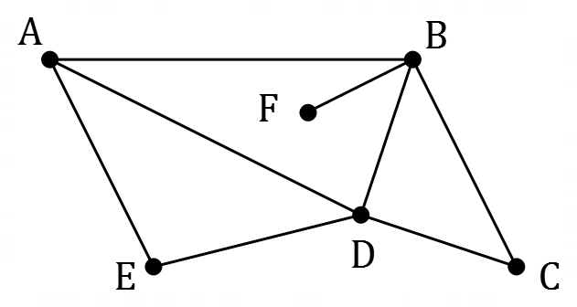
(b) The graph shown to the right represents
unsealed tracks between six barns on
the farm.

(i) State the length of the longest cycle in the graph. (1 mark)

(ii) Explain why the graph is not Hamiltonian. (1 mark)

(iii) An edge can be added to the graph so that it becomes Hamiltonian. State a pair of vertices between which such an edge should be added. (1 mark)

Question 2 (5 marks)
The daily number of gas bottle refills ($n$) over a period of three weeks at a service station is shown in the plot below. The Monday of Week 1 corresponds to $t=1$.

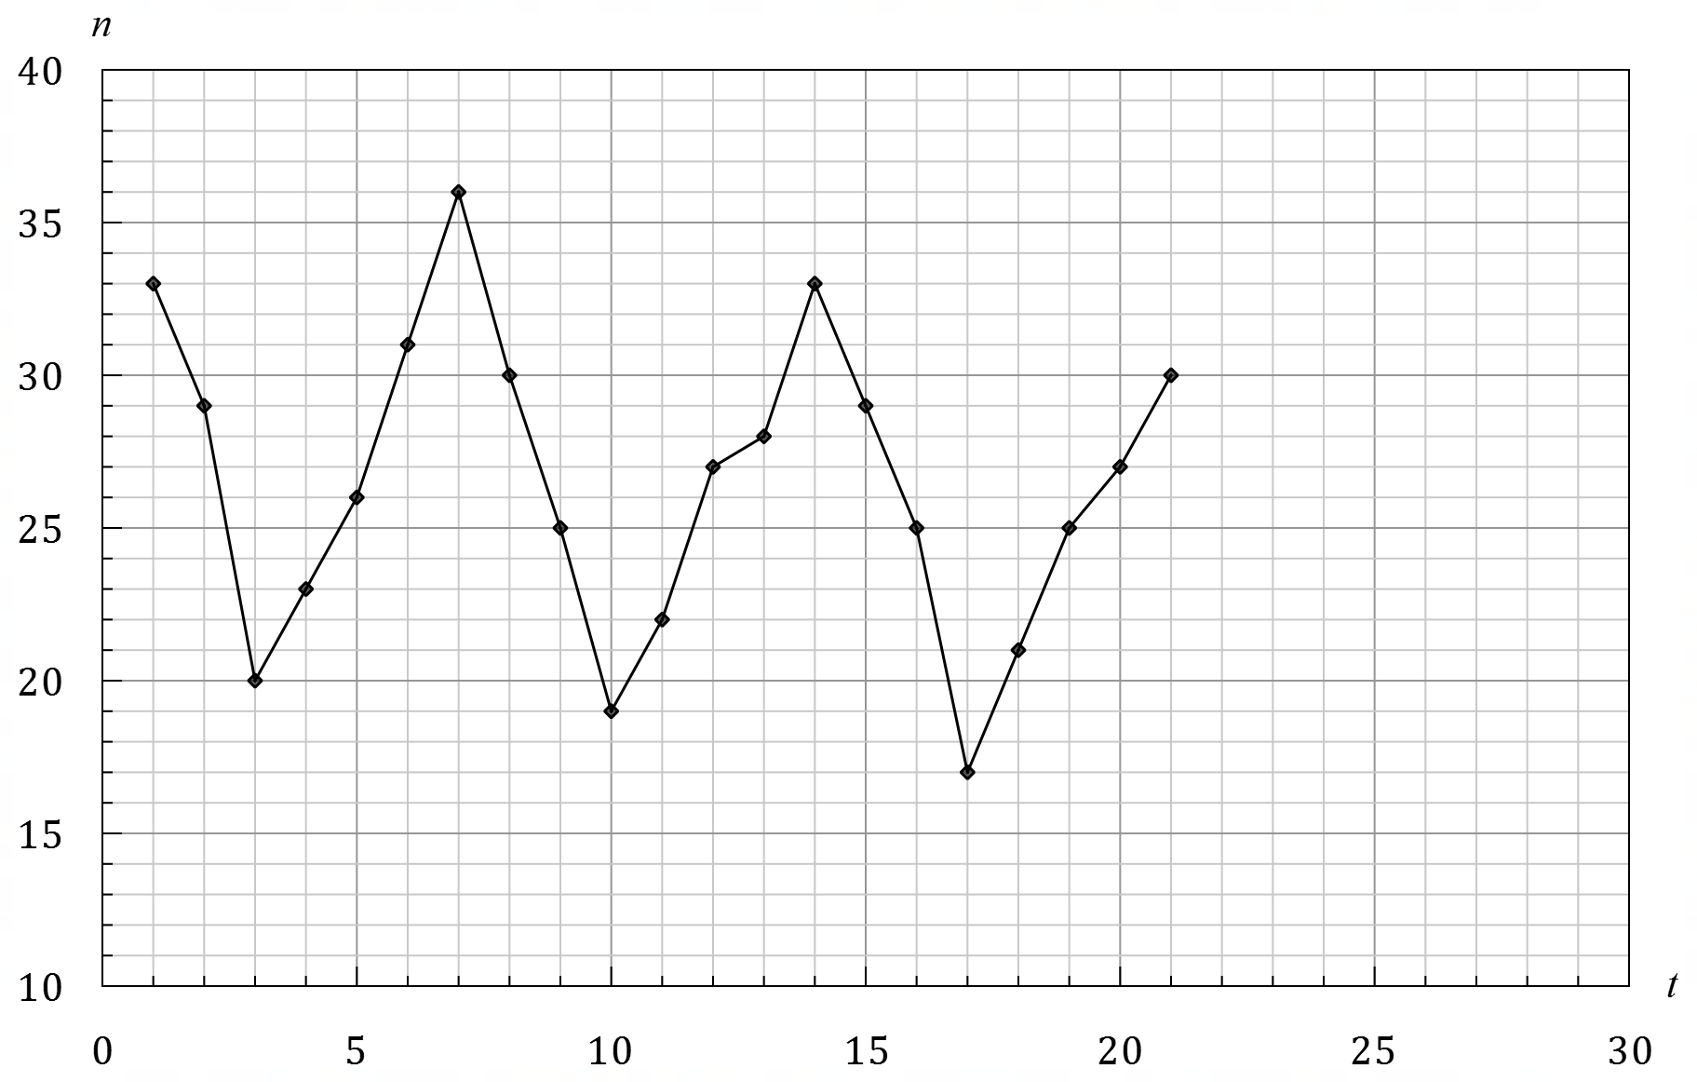

The number of refills during Week 4 are shown in the table below.

Day | Mon | Tue | Wed | Thu | Fri | Sat | Sun
Time, $t$ | $$22$$ | $$23$$ | $$24$$ | $$25$$ | $$26$$ | $$27$$ | $$28$$
Refills, $n$ | $$26$$ | $$23$$ | $$17$$ | $$20$$ | $$11$$ | $$27$$ | $$29$$

(a) Complete the time series plot by adding the above data for Week 4. (2 marks)

(b) Describe the trend, seasonality and any other features of the time series plot. (3 marks)

Question 3 (7 marks)
An employee at a reticulation company represented three lawn watering systems using
graphs $G_{1}$, $G_{2}$ and $G_{3}$.
(a) Graph $G_{1}$ has adjacency matrix $\left[\begin{matrix}0 & 1 & 0 & 1 & 1 \\ 1 & 0 & 2 & 0 & 1 \\ 0 & 2 & 0 & 1 & 0 \\ 1 & 0 & 1 & 0 & 0 \\ 1 & 1 & 0 & 0 & 1\end{matrix}\right]$.
Draw graph $G_{1}$in the plane, labelling the vertices $1, 2, 3, 4$ and $5$. (3 marks)

(b) Graph $G_{2}$ is a connected planar graph with $18$ edges and $11$ faces.
Determine the number of vertices in graph $G_{2}$. (2 marks)

(c) Graph $G_{3}$ has $5$ vertices, is a tree, and the longest trail it contains has length $3$.
Draw graph $G_{3}$. (2 marks)

Question 4 (6 marks)
A computer is running some image recognition software that is learning a new task.
On the $n^{th}$ run of the software, the time taken to complete the task, $T_{n}$ milliseconds, is given by the recurrence relation
$$T_{n+1}=0.5T_{n}+2, T_{1}=20.$$

(a) Use the recurrence relation to complete the table below. (2 marks)

$$n$$ | $$1$$ | $$2$$ | $$3$$ | $$4$$ | $$5$$ | $$6$$
$$T_{n}$$

(b) Plot the times on the axes below. (2 marks)

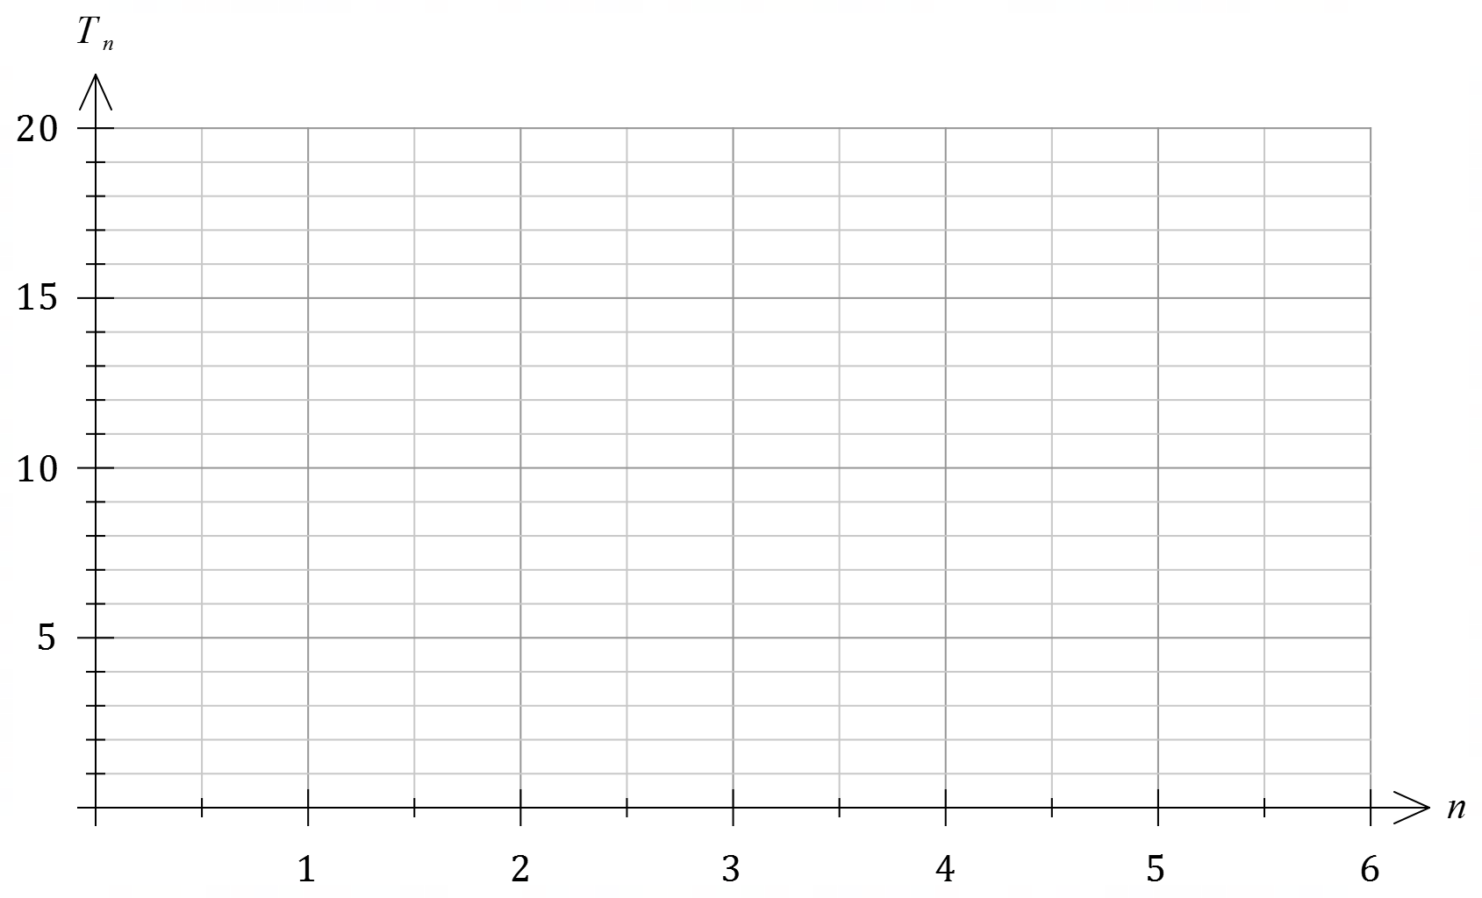

(c) According to the recurrence relation, the time taken to complete the task will never be quicker than $t$ milliseconds. Determine, with justification, the value of $t$. (2 marks)

Question 5 (7 marks)
Four workers, A, B, C and D, are each to be assigned to one of four tasks, 1, 2, 3 and 4. Each worker must be assigned to one task, and each task must be done by exactly one worker. Worker C cannot be assigned to task 3. The profit, in dollars, that each worker would generate when assigned to each task is shown in the table below.

 | 1 | 2 | 3 | 4
A | $$76$$ | $$51$$ | $$90$$ | $$64$$
B | $$79$$ | $$60$$ | $$79$$ | $$59$$
C | $$71$$ | $$54$$ | 0 | $$62$$
D | $$73$$ | $$56$$ | $$85$$ | $$70$$

(a) Modify the table as required so that the Hungarian algorithm may be applied to the resulting figures in order to determine the maximum total profit that can be generated by the four workers. (2 marks)

(b) Reducing rows first, use the Hungarian algorithm to determine the maximum total profit and the assignment of workers required to achieve this maximum. (5 marks)

Question 6 (11 marks)
(a) The tasks required to complete a project are shown in the table below, together with the duration of each task in days, and their immediate predecessor(s).

Task | Duration (days) | Immediate predecessor(s)
A | $$10$$ | None
B | $$15$$ | None
C | $$5$$ | A
D | $$20$$ | B
E | $$15$$ | B
F | $$10$$ | C
G | $$25$$ | C
H | $$5$$ | D
J | $$5$$ | D, E
K | $$30$$ | D, E
L | $$20$$ | G, H, J

(i) Construct a project network to represent the information in the table. (4 marks)

(ii) State the earliest time that task G can commence. (1 mark)

(b) The network showing the tasks that need to be undertaken to complete a different project is shown below. The duration of each task, in minutes, is shown in brackets.

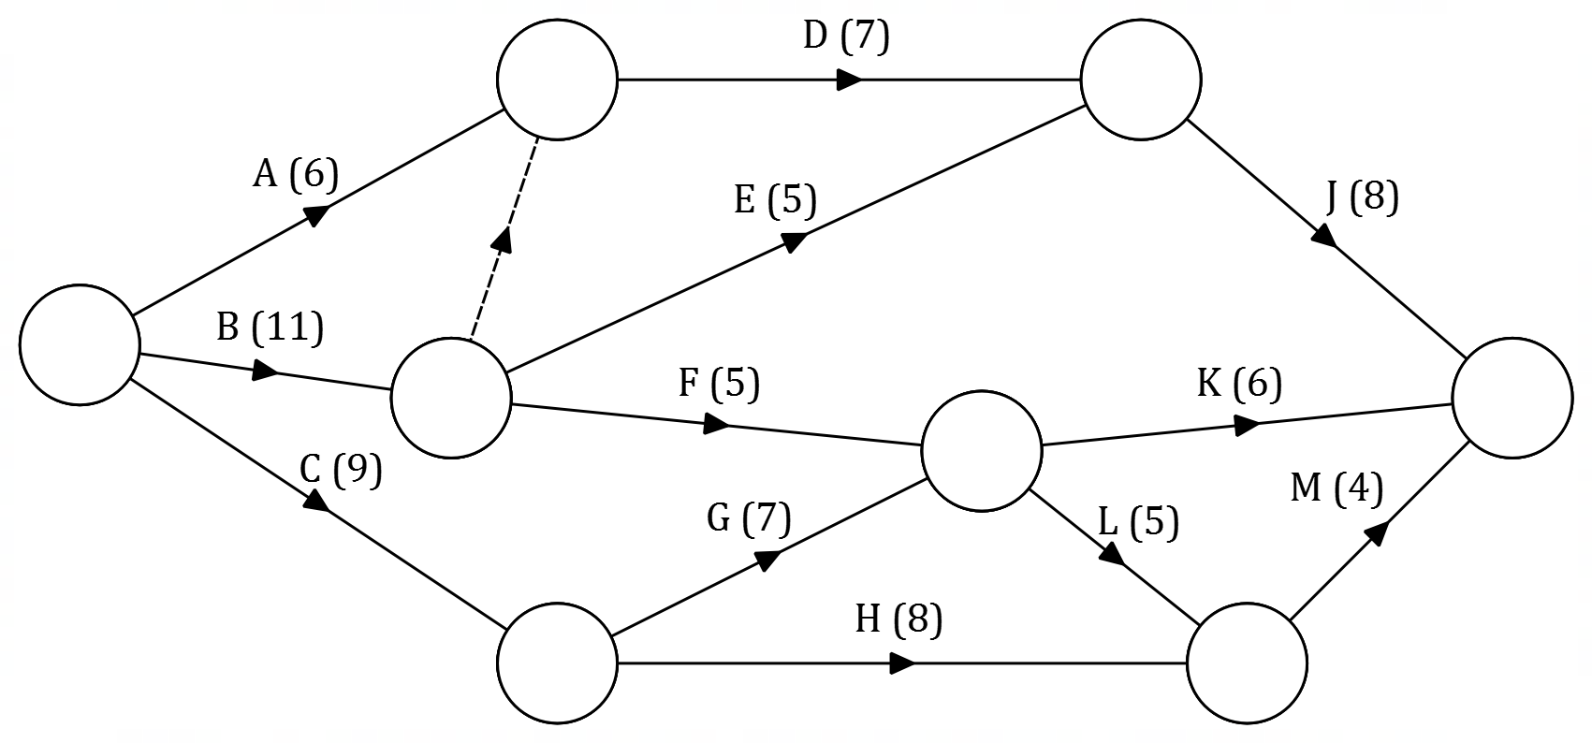

(i) What does the dotted line on the network indicate? (1 mark)

(ii) Determine, in order, the tasks that lie on the critical path and the minimum completion time for the project. (2 marks)

(iii) Determine the float time for task H. (1 mark)

(iv) If task B could be completed in only $8$ minutes, how would this affect the critical path and minimum completion time? (2 marks)

Question 7 (8 marks)
The edges in the graph below represent footpaths between buildings (shown as vertices) on the extensive campus of a research centre. Each edge weight represents the time, in minutes, that a supervisor takes to walk along that footpath to check that it is clean and in good condition.

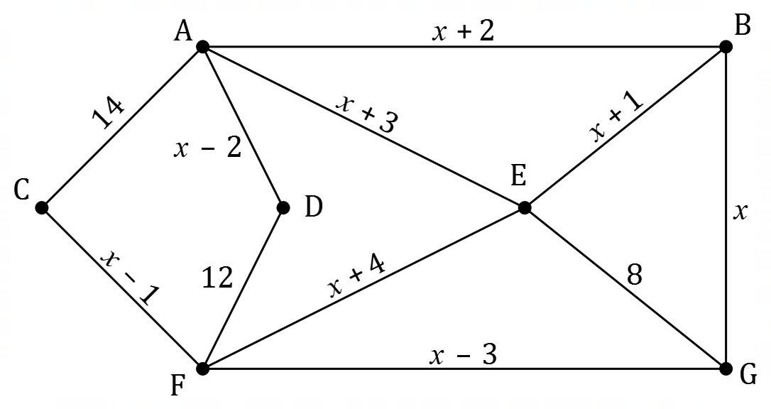

(a) State, with justification, whether the graph is Eulerian, semi-Eulerian or neither. (2 marks)

The supervisor's office is in building $B$. The least time that the supervisor takes to complete an inspection of all footpaths and return to their office is $182$ minutes.

(b) Determine the value of $x$, the time to walk along the footpath from $B$ to $G$. (4 marks)

(c) The supervisor is in their office. At $8:25$ am, they are asked to inspect the footpath between buildings $D$ and $F$. Determine the earliest time that they could finish the inspection of this footpath if they left their office immediately. (2 marks)

Supplementary page

Question number: _________

Supplementary page

Question number: _________

© 2022 WA Exam Papers. Mater Dei College has a non-exclusive licence to copy and communicate this document for non-commercial, educational use within the school. No other copying, communication or use is permitted without the express written permission of WA Exam Papers. SN061-206-1.

